What is climate change? A really simple guide bbc.co.uk
- 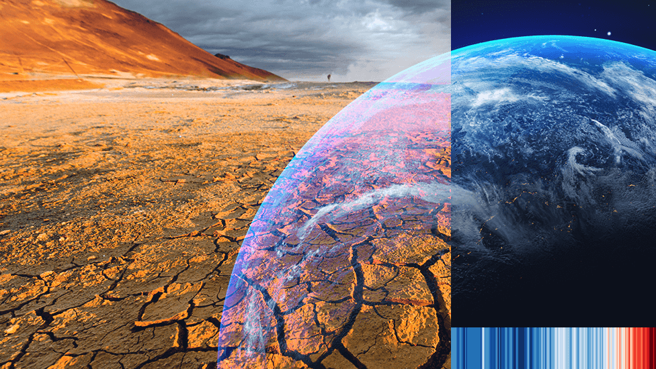IMAGE SOURCE,GETTY IMAGES
Human activities are causing world temperatures to rise, with more intense heatwaves and rising sea-levels among the consequences.
Things are likely to worsen in the coming decades, but scientists argue urgent action can limit the worst effects of climate change.
What is climate change?
Climate change is the long-term shift in the Earth's average temperatures and weather conditions.
Over the last decade, the world was on average around 1.2C warmer than during the late 19th Century.
It has now been confirmed that global warming exceeded 1.5C across the 12 month period between February 2023 and January 2024. That followed 2023 being declared the warmest year on record.
The temperature increase was driven by human-caused climate change and boosted by the natural El Niño weather phenomenon.
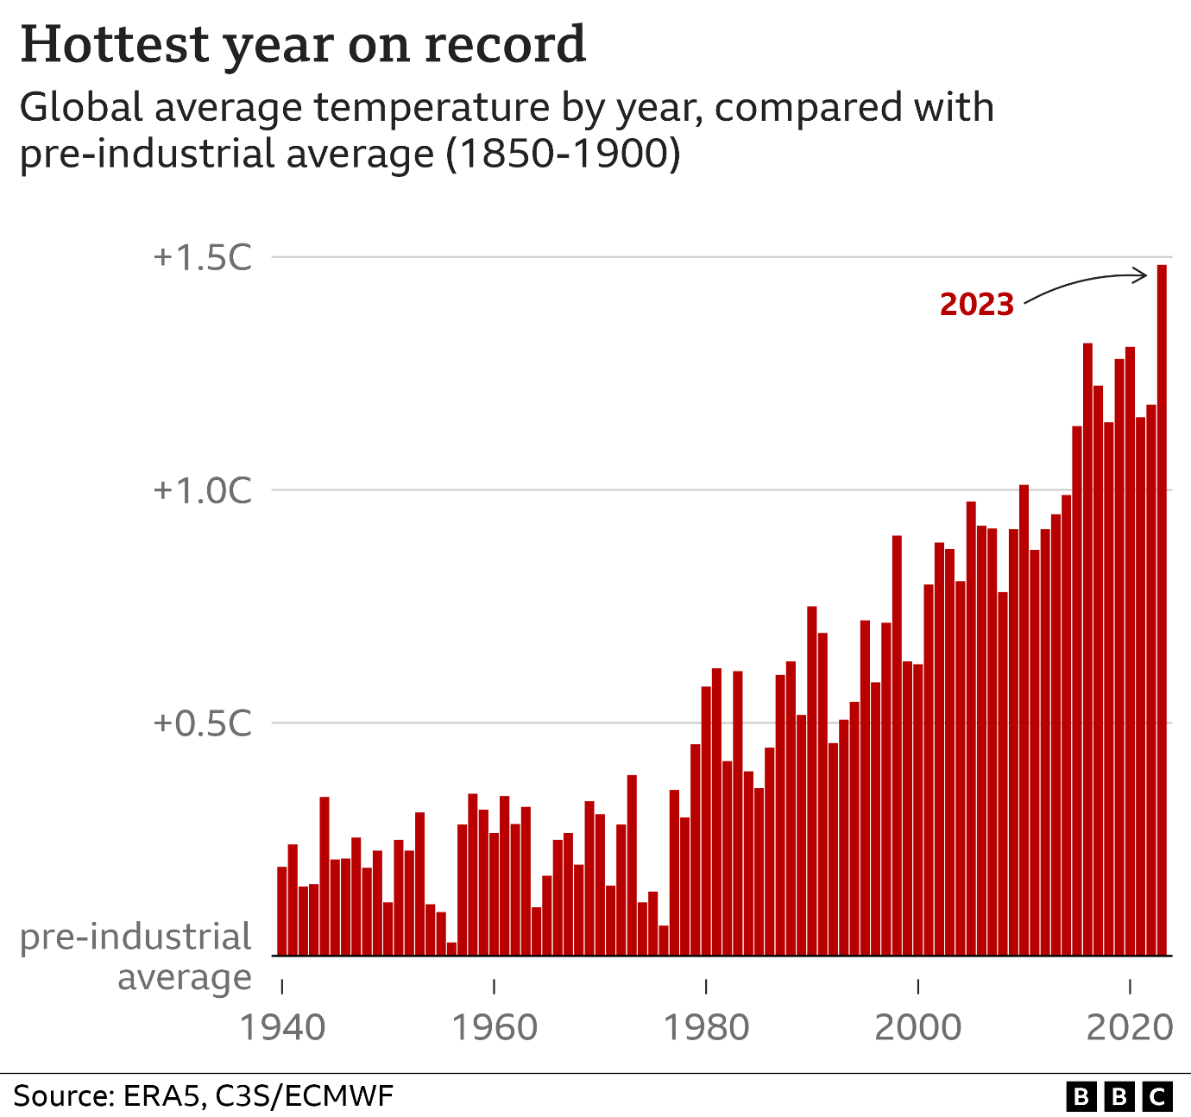
How are humans causing climate change?
The climate has changed throughout the Earth's history and natural factors, such as El Niño, can affect the weather for shorter periods of time, as happened in 2023.
But natural causes cannot explain the particularly rapid warming seen in the last century, according to the UN's climate body, the IPCC.
This long-term climate change has been caused by human activity, the IPCC says, mainly from the widespread use of fossil fuels - coal, oil and gas - in homes, factories and transport.
When fossil fuels burn, they release greenhouse gases - mostly carbon dioxide (CO2). This traps extra energy in the atmosphere near the Earth's surface, causing the planet to heat up.
Since the start of the Industrial Revolution - when humans started burning large amounts of fossil fuels - the amount of CO2 in the atmosphere has risen by about 50%.
The CO2 released from burning fossil fuels has a distinctive chemical fingerprint which matches the type increasingly found in the atmosphere.
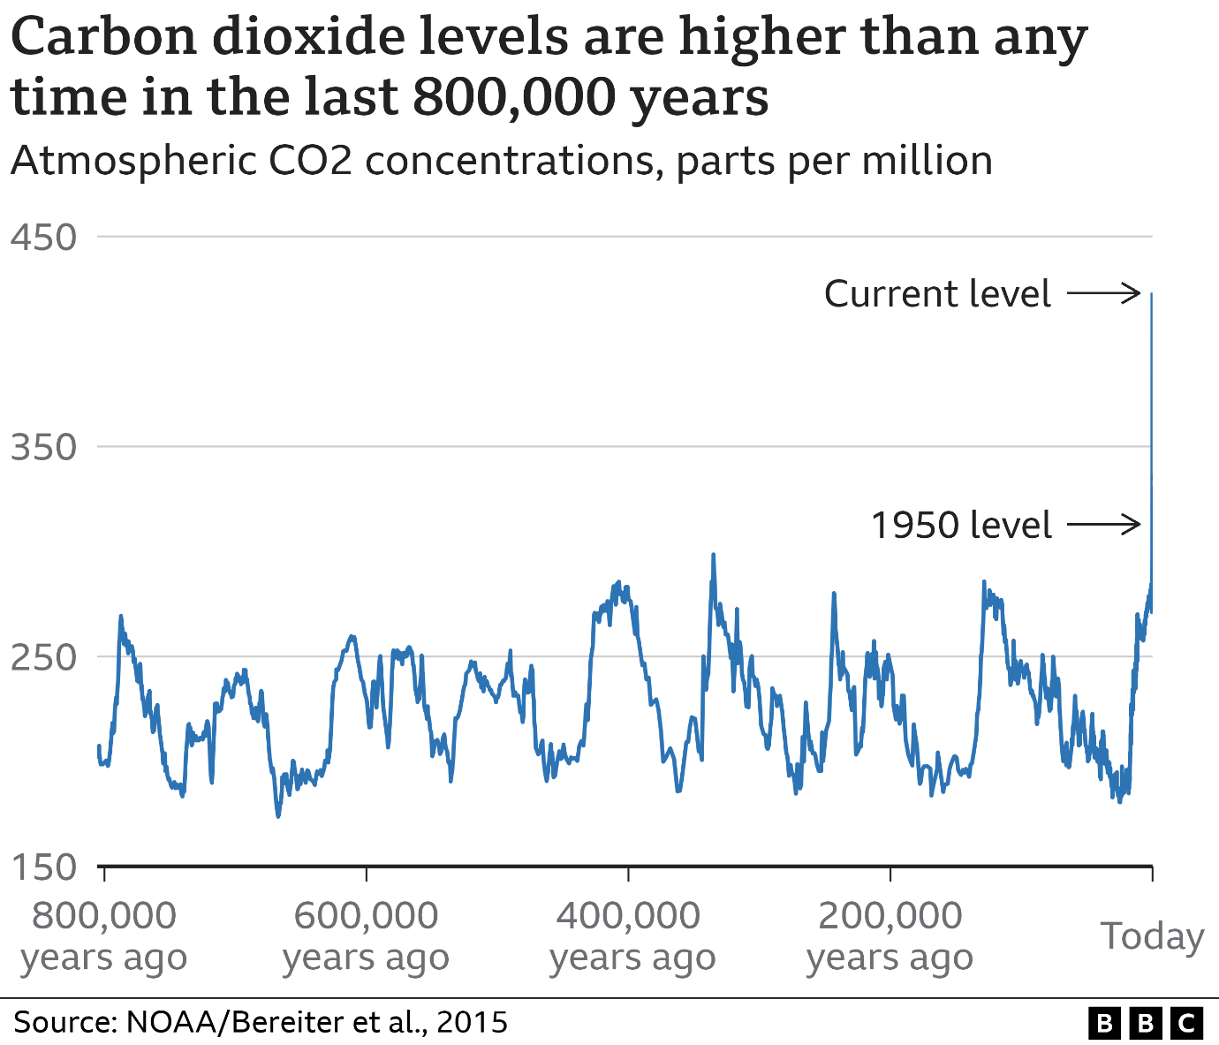
What are the effects of climate change so far?
The global average temperature increase of 1.2C seen in the past decade might not sound much.
However, it has had a huge effect on the environment, including:
- more frequent and intense extreme weather, such as heatwaves and heavy rainfall
- rapid melting of glaciers and ice sheets, contributing to sea-level rise
- huge declines in Arctic sea-ice
- ocean warming
People's lives are also changing.
For example, parts of East Africa suffered their worst drought in 40 years, putting more than 20 million people at risk of severe hunger.
In 2022, intense European heatwaves led to an abnormal increase in deaths.
Why does 1.5C matter and how will future climate change affect the world?
The more average temperatures increase, the worse the impacts of climate change become.
Limiting long-term average temperature rises to 1.5Cis crucial, according to the IPCC.
The science is not completely certain, but the consequences of 2C global warming versus 1.5C could include:
- Extreme hot days would be on average 4C warmer at mid-latitudes (regions outside the poles and tropics), versus 3C at 1.5C
- Sea-level rise would be 0.1m higher than at 1.5C, exposing up to 10 million more people to events including more frequent flooding
- More than 99% of coral reefs would be lost, compared with 70-90% at 1.5C
- Twice the number of plants and vertebrates (animals with a backbone) would be exposed to unsuitable climate conditions across more than half the geographical area where they are found
- Several hundred million more people may be exposed to climate-related risks and susceptible to poverty by 2050 than at 1.5C.
The call to limit temperature rise to 1.5C was partly designed to avoid crossing so-called "tipping points".
After these thresholds are passed, changes could accelerate and become irreversible, such as the collapse of the Greenland Ice Sheet. However, it's not clear precisely where these thresholds sit.
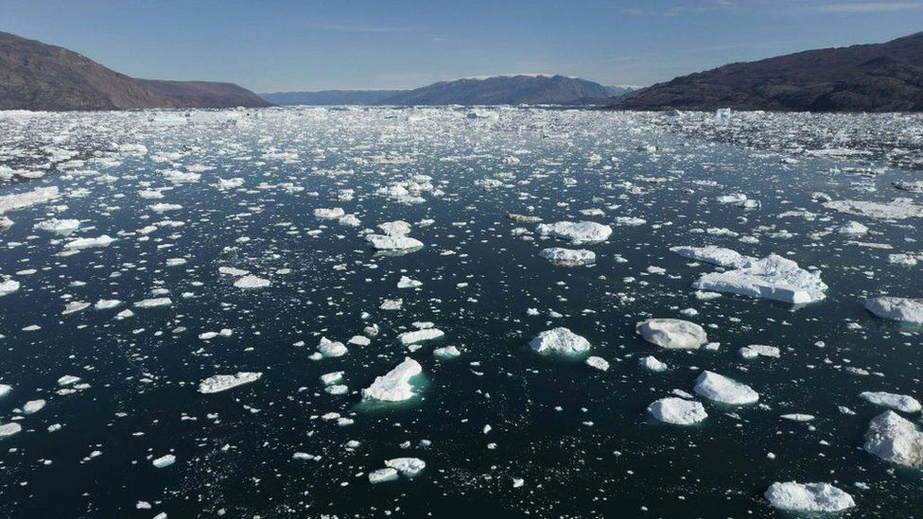IMAGE SOURCE,GETTY IMAGES
Image caption,
The Earth's poles are especially vulnerable to rising temperatures
About 3.3 to 3.6 billion people are highly vulnerable to climate change, according to the IPCC.
People living in poorer countries are expected to suffer most as they have fewer resources to adapt.
This has led to questions about fairness, because these places have typically only been responsible for a small percentage of greenhouse gas emissions.
However, knock-on impacts could be felt over wide areas. For example, crop failures linked to extreme weather could raise global food prices.
What are governments doing about climate change?
In a landmark agreement signed in Paris in 2015, almost 200 countries pledged to try to keep global warming to 1.5C.
To achieve this, "net zero" CO2 emissions should be reached by 2050. Net zero means reducing greenhouse gas emissions as much as possible, and removing any remaining emissions from the atmosphere.
Most countries have, or are considering, net zero targets.
However, greenhouse gas levels are still rising quickly and the world is "likely" to warm beyond 1.5C, the IPCC says.
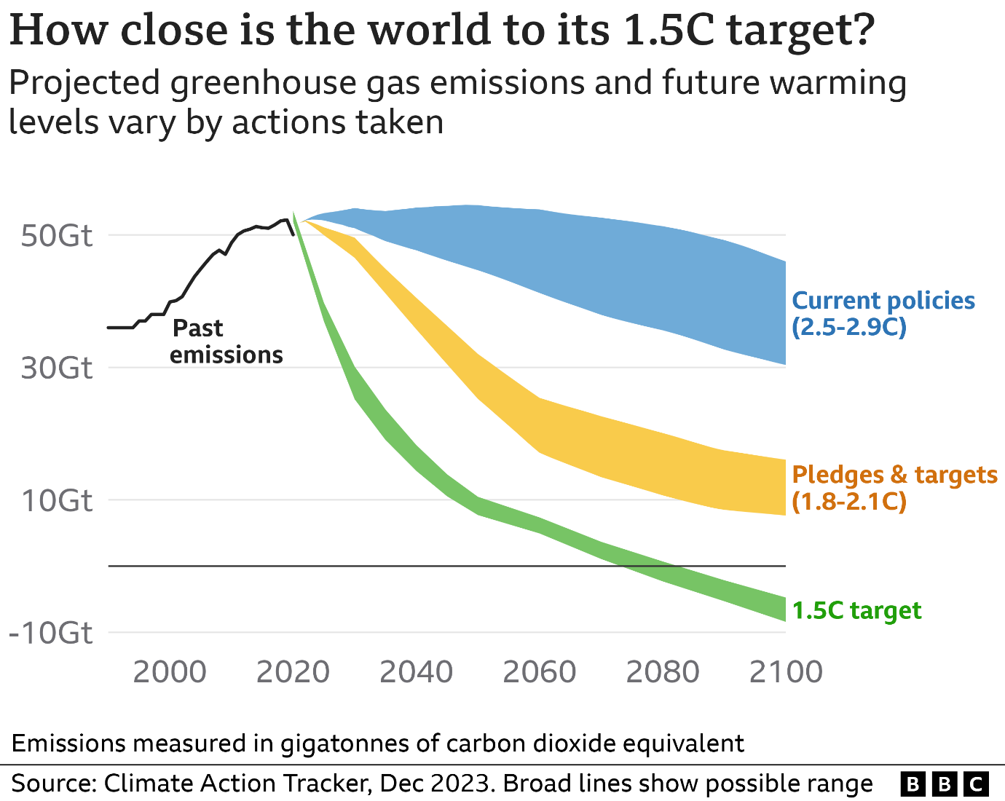
However, there has been progress in some areas such as the growth of renewable energy and electric vehicles.
World leaders meet every year to discuss their climate commitments.
The most recent UN climate change summit, COP28, was held in the United Arab Emirates. For the first time, countries agreed to "contribute" to "transitioning away from fossil fuels", although they are not forced to take action.
The next conference, COP29, will be held in Azerbaijan in November 2024.
What can individuals do about climate change?
Major changes need to come from governments and businesses, but individuals can also help:
- take fewer flights
- use less energy
- improve home insulation and energy efficiency
- switch to electric vehicles or live car-free
- replace gas central heating with electric systems like heat pumps
- eat less red meat
Top image from Getty Images. Climate stripes visualisation courtesy of Prof Ed Hawkins and University of Reading
bbc.co.uk 8 February 2024

